**EXPERIMENT NO 1**

**Date of Completion:** -29th January 2022

**Name:** -Tambe Manish Mangesh

**Roll No: -** 221080

**Gr No: -** 22120186, **Batch: -** ‘DSY’

**AIM: - Study the Basic Linux commands**

**The following are some basic Linux commands.**

1. **pwd: -** The pwd command is used to display the location of the current working directory.

**Output:** -

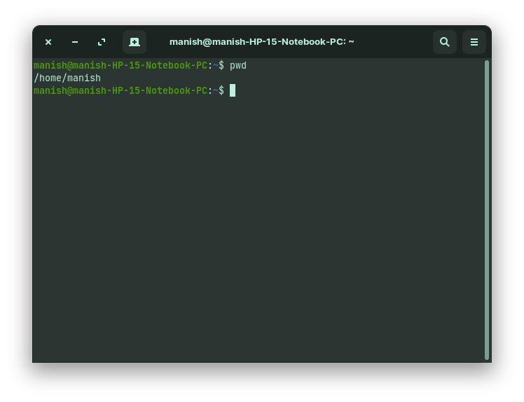

1. **man: -** man command in Linux is used to display the user manual of any command that we can run on the terminal.

**Output:** -

**Before:** -

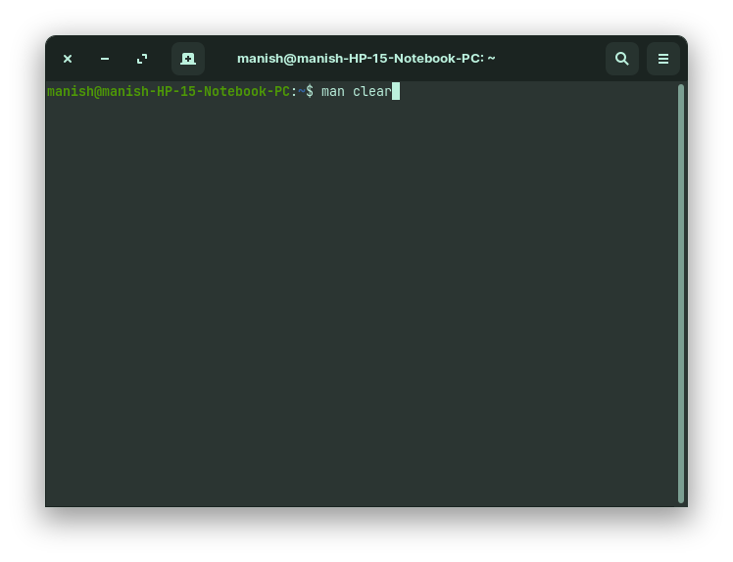

**After: -**

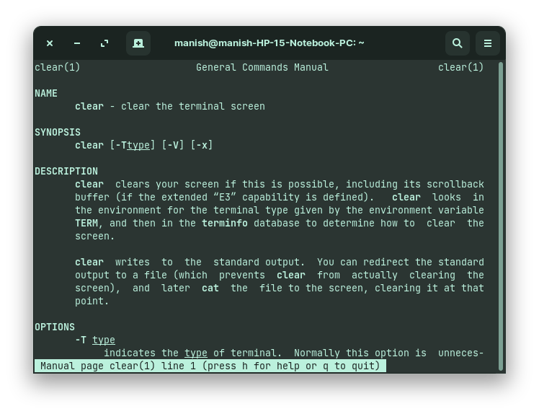

1. **clear: -** Linux clear command is used to clear the terminal screen.

**Output: -**

**Before: -**

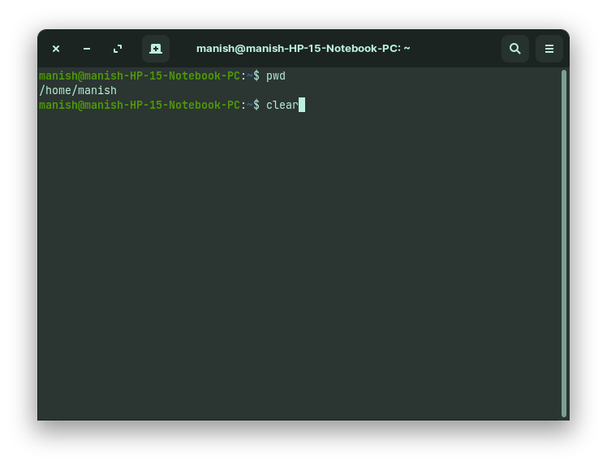

**After: -**

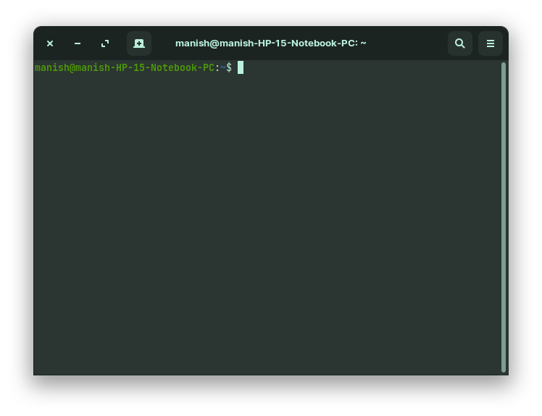

1. **ls: -** The [ls](https://www.javatpoint.com/linux-ls) command is used to display a list of content of a directory.

**Output: -**

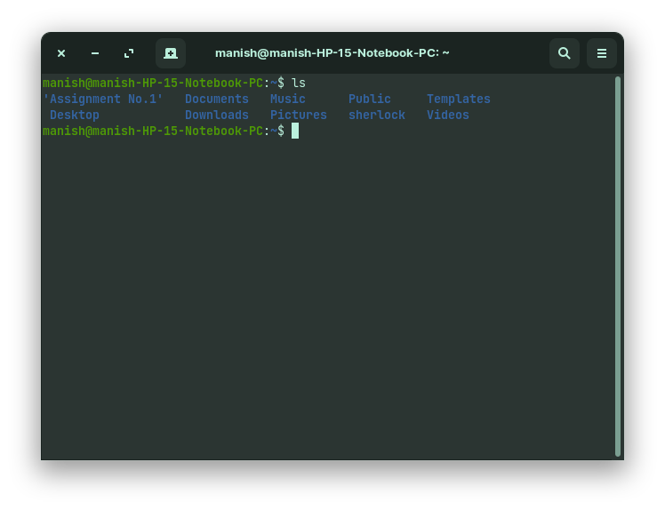

1. **cd: -** The cd command is used to change the current directory.

**Output: -**

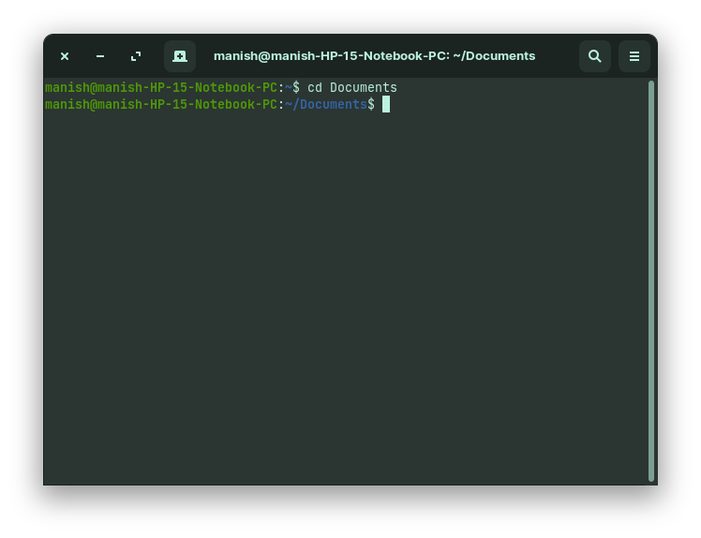

1. **touch: -**The touch command is used to create empty files. We can create multiple empty files by executing it once.

**Output: -**

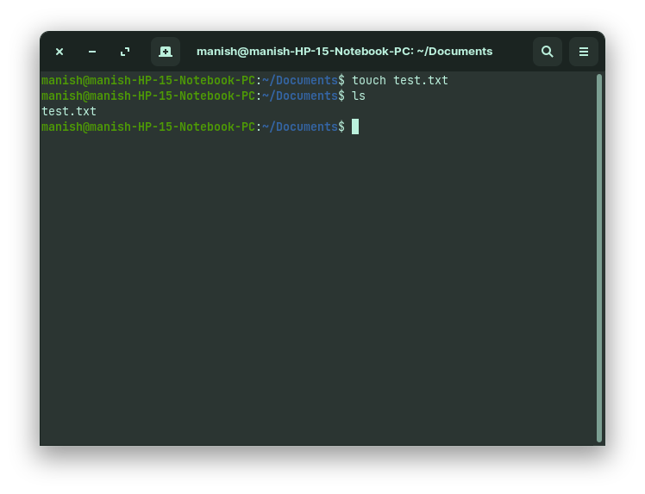

1. **cat: -**The cat command is a multi-purpose utility in the Linux system. It can be used to create a file, display content of the file, copy the content of one file to another file, and more.

**Output: -**

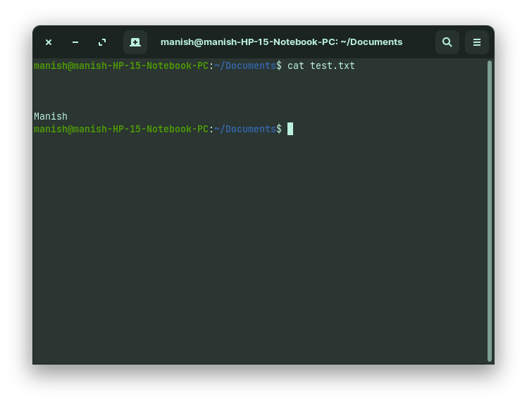

1. **mkdir: -** The mkdir command is used to create a new directory under any directory.

**Output: -**

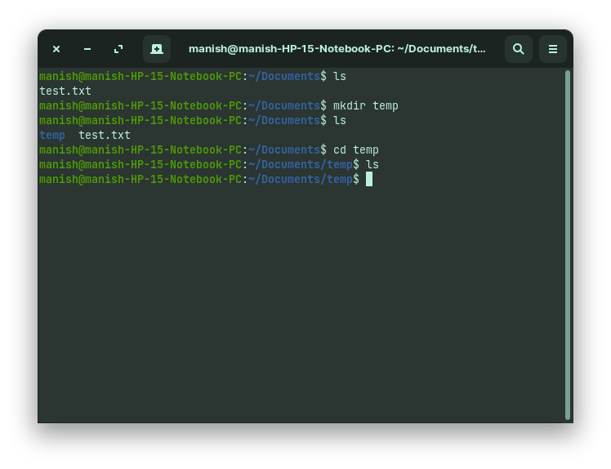

1. **rmdir: -** The rmdir command is used to delete a directory.

**Output: -**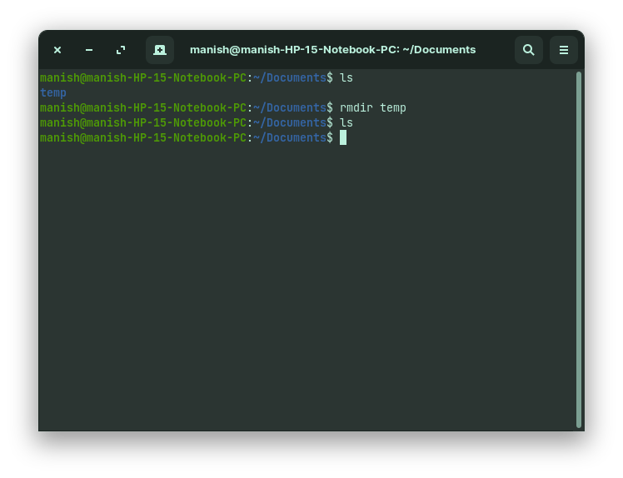

1. **rm: -** The rm command is used to remove a file.

**Output: -**

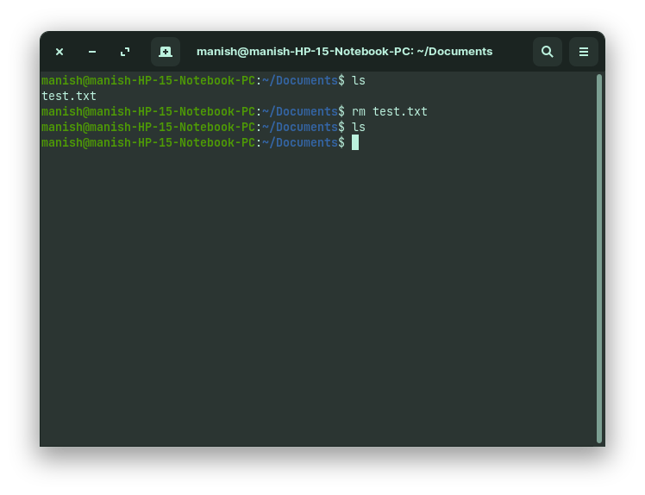

1. **date: -** The date command is used to display date, time, time zone, and more.

**Output: -**

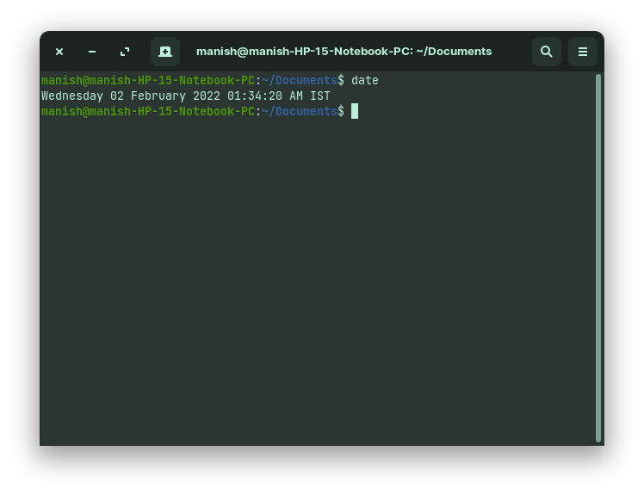

1. **mv: -** The mv command is used to move a file or a directory form one location to another location.

**Output: -**

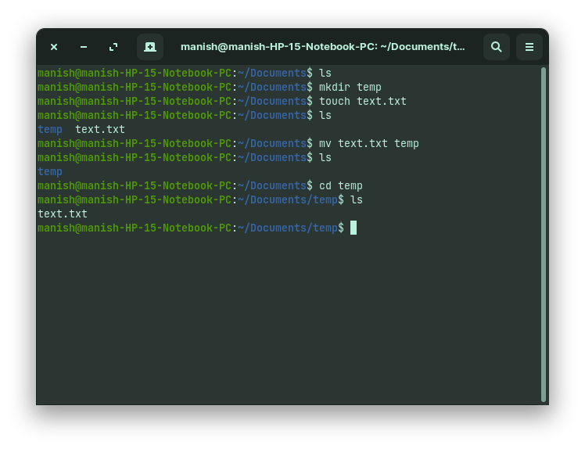

1. **cal: -** The cal command is used to display the current month's calendar with the current date highlighted.

**Output: -**

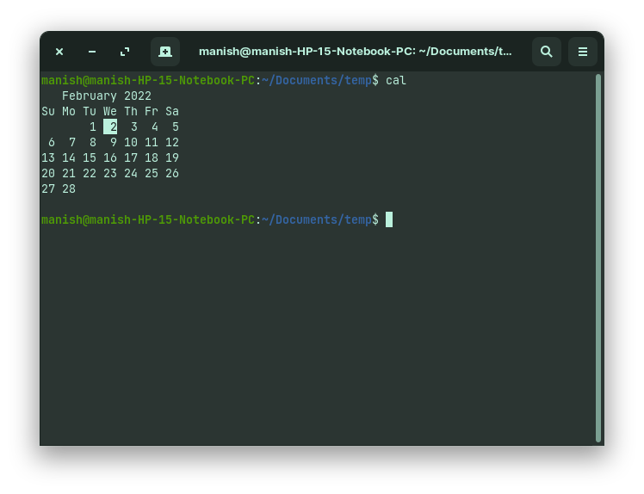

1. **exit: -** Linux exit command is used to exit from the current shell. It takes a parameter as a number and exits the shell with a return of status number.

**Output: -**

**Before: -**

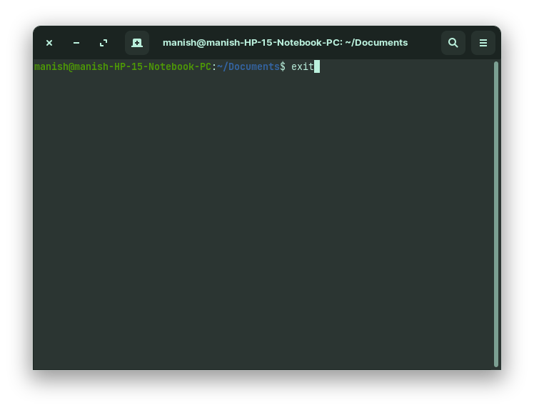

**After: -**

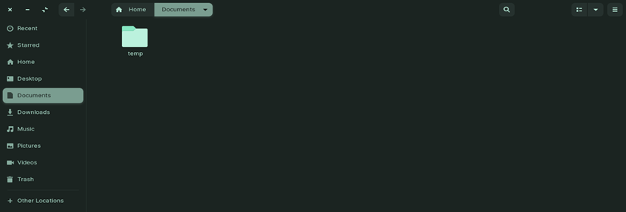

1. **ps: -** This command is used to list the currently running processes and their PIDs along with some other information depends on different options.

**Output: -**

